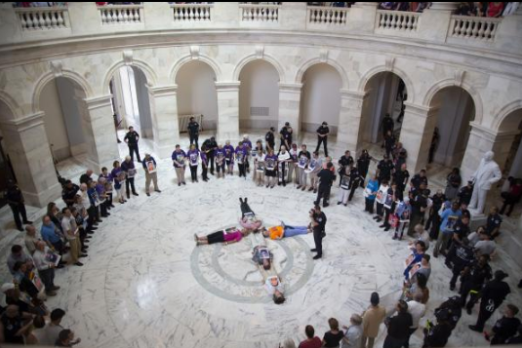

Catholic Action with Immigrant Children

Parish Prayer #1

Gathering and Welcome
Welcome! We gather today in the presence of our God of infinite love and compassion. Our God has called us here today to bear witness to the dignity of every human person and to hold our elected representatives accountable for the atrocities perpetrated on our brothers and sisters—immigrants, refugees, and asylum seekers—mothers, fathers, aunts and uncles. We remember especially the children—frightened, alone, hungry, and cold. These are God’s children—our children! We must not—we will not—let this continue. We pray loudly, clearly: Stop the inhumanity—NOW! We are here today to stand with God’s precious children. They cry out and so we must speak.

Litany Naming the Children with Response

We bow our heads in prayer and we remember the children known
to have died in U.S. custody since December 2018

Jakelin Caal Maquin: Guatemala: Age 7: December 8, 2018 “ We Remember You”

Felipe Gomez Alonzo: Guatemala: Age 8: December 24, 2018 “ We Remember You”

Juan De Leon Gutierrez: Guatemala: Age 16: April 30, 2019 “ We Remember You”

Mariee Juarez: Guatemala: Age 1: May 10, 2018 “ We Remember You”

Wilmer Josue Ramirez Vazquez: Guatemala: Age 2: May 14, 2019 “ We Remember You”

Carlos Gregorio Hernandez Vasquez: Guatemala: Age 16: May 20, 2019 “ We Remember You”

Darlyn Cristabel Cordova Valle: El Salvador: Age 10: May 29, 2019 “ We Remember You”

Wilmer Josue Ramirez Vazquez: Guatemala: Age 2: May 14, 2019 “ We Remember You”

Optional Decade of the Rosary

Closing Prayer
Merciful God, through your grace, may we imitate your love and show true compassion by welcoming the immigrant and the refugee, and Inspired by the teaching of Jesus, may we greet each stranger as neighbor, receive and care for children as your own children, and may we live in the peace that comes from your love.

