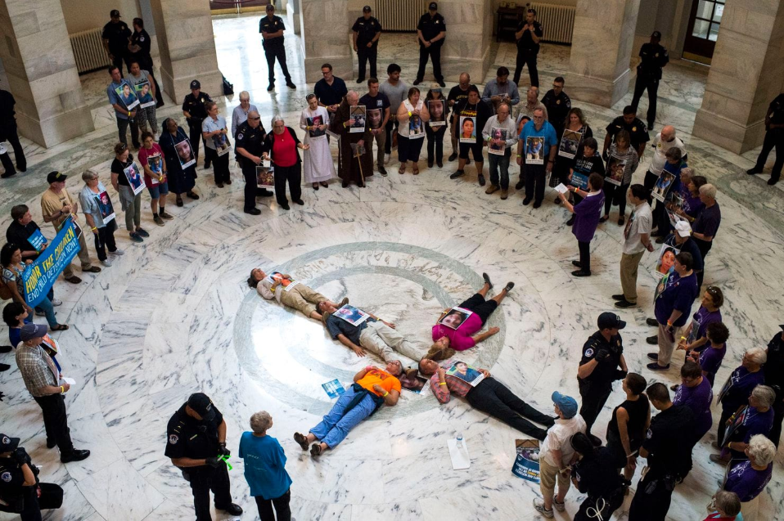

Catholic Action with Immigrant Children

Community Vigil #1

Gathering and Welcome
Welcome! We gather today in the presence of our God of infinite love and compassion. Our God has called us here today to bear witness to the dignity of every human person and to hold our elected representatives accountable for the atrocities perpetrated on our brothers and sisters—immigrants, refugees, and asylum seekers—mothers, fathers, aunts and uncles. We remember especially the children—frightened, alone, hungry, and cold. These are God’s children—our children! We must not—we will not—let this continue. We pray loudly, clearly: Stop the inhumanity—NOW! We are here today to stand with God’s precious children. They cry out and so we must speak.

Opening Song: Suggested “All Are Welcome” (Marty Haugen) All Are Welcome

Let us build a house
where love can dwell
And all can safely live,
A place where
saints and children tell
How hearts learn to forgive.

Built of hopes and dreams and visions,
Rock of faith and vault of grace;
Here the love of Christ shall end divisions;
Let us build a house where prophets speak,
And words are strong and true,
Where all God's children dare to seek
To dream God's reign anew.

Here the cross shall stand as witness
And a symbol of God's grace;
Here as one we claim the faith of Jesus:
Let us build a house where love is found
In water, wine and wheat:
A banquet hall on holy ground,
Where peace and justice meet.

Here the love of God, through Jesus,
Is revealed in time and space;
As we share in Christ the feast that frees us:
All are welcome, all are welcome,
All are welcome in this place.

Litany Naming the Children with Response

We bow our heads in prayer and we remember the children known
to have died in U.S. custody since December 2018

Jakelin Caal Maquin: Guatemala: Age 7: December 8, 2018 “ We Remember You”

Felipe Gomez Alonzo: Guatemala: Age 8: December 24, 2018 “ We Remember You”

Juan De Leon Gutierrez: Guatemala: Age 16: April 30, 2019 “ We Remember You”

Mariee Juarez: Guatemala: Age 1: May 10, 2018 “ We Remember You”

Wilmer Josue Ramirez Vazquez: Guatemala: Age 2: May 14, 2019 “ We Remember You”

Carlos Gregorio Hernandez Vasquez: Guatemala: Age 16: May 20, 2019 “ We Remember You”

Darlyn Cristabel Cordova Valle: El Salvador: Age 10: May 29, 2019 “ We Remember You”

Wilmer Josue Ramirez Vazquez: Guatemala: Age 2: May 14, 2019 “ We Remember You”

Readings

A 12-year-old from Guatemala at a border patrol facility describes his hunger:
“The guards were mean and scary. They yelled at us. One day the guards wanted to know if anyone had snuck food in the cell. They found one kid who was about 15 or 16 years old who had a burrito, pudding, and juice. The officials handcuffed his wrists. I’m hungry all the time. I’m so hungry that I’ve woken up in the middle of the night with hunger. I’m too scared to ask the officials here for any more food, even though there is not enough food here for me. In the morning we get oatmeal, pudding, and juice. In the afternoon we get soup, a cookie, and juice. For dinner we get a burrito, pudding and juice. I saw a child ask for more food once and the guard told him ‘No, you’ve had your ration.’ Sometimes the younger kids get an extra chocolate pudding. I need more food too.”
Lord have mercy.
Response: Lord Have Mercy

Pope Francis in his message for the World Day of Migrants and Refugees says:
“It is not just about migrants: it is also about our fears. The signs of meanness we see around us heighten our fear of ‘the other’, the unknown, the marginalized, the foreigner... We see this today in particular, faced with the arrival of migrants and refugees knocking on our door in search of protection, security and a better future. To some extent, the fear is legitimate, also because the preparation for this encounter is lacking. But the problem is not that we have doubts and fears. The problem is when they condition our way of thinking and acting to the point of making us intolerant, closed and perhaps even – without realizing it – racist. In this way, fear deprives us of the desire and the ability to encounter the other, the person different from myself; it deprives me of an opportunity to encounter the Lord.”
Christ have mercy.
Response: Christ Have Mercy

The Gospel according to Mark says:
“People were bringing children to him that he might touch them, but the disciples rebuked them. When Jesus saw this he became indignant and said to them, ‘Let the children come to me; do not prevent them, for the kingdom of God belongs to such as these. Amen, I say to you, whoever does not accept the kingdom of God like a child will not enter it.’ Then he embraced them and blessed them, placing his hands on them.”
Lord have mercy.
Response: Lord Have Mercy

Responsorial Psalm

Psalm Response: Who Will Speak If We Don’t? Who will speak so their voice will be heard?
(from Marty Haugen, “Who Will Speak If We Don’t”)

Blessed the one whose help is the God of Jacob, whose hope is in the Lord, his God, the maker of heaven and earth, the seas and all that is in them, who keeps faith forever, secures justice for the oppressed, who gives bread to the hungry.
Response: Who Will Speak If We Don’t? Who will speak so their voice will be heard?

The Lord sets prisoners free; the Lord gives sight to the blind. The Lord raises up those who are bowed down;
the Lord loves the righteous.
Response: Who Will Speak If We Don’t? Who will speak so their voice will be heard?

The Lord sets prisoners free; the Lord gives sight to the blind. The Lord raises up those who are bowed down;
the Lord loves the righteous.
Response: Who Will Speak If We Don’t? Who will speak so their voice will be heard?

The Lord protects the foreigner, comes to the aid of the orphan and the widow, but thwarts the way of the wicked.
Response: Who Will Speak If We Don’t? Who will speak so their voice will be heard?

The Lord shall reign forever, your God, Zion, through all generations! Hallelujah!
Response: Who Will Speak If We Don’t? Who will speak so their voice will be heard?

Prayers of Petition

For those forced to flee their countries of origin because of fear, violence, corruption, and poverty, we cry out,
Response: Stop the Inhumanity

For the president, his staff and Cabinet, for members of Congress and all who are complicit in inflicting suffering and harm on immigrants, asylum seekers, and refugees that they repent, end the torture and stop the violence, we cry out,
Response: Stop the Inhumanity

For those forced to flee their countries of origin because of fear, violence, corruption, and poverty, we cry out,
Response: Stop the Inhumanity

For the president, his staff and Cabinet, for members of Congress and all who are complicit in inflicting suffering and harm on immigrants, asylum seekers, and refugees that they repent, end the torture and stop the violence, we cry out,
Response: Stop the Inhumanity

For all who denigrate and scapegoat immigrants and refugees for their own political gain, that they might see the profound harm they have done to the fabric of our nation and seek instead the common good, we cry out,
Response: Stop the Inhumanity

For the children who have been taken from their families and incarcerated by our government and for those who love them and pray for their safe return, we cry out,
Response: Stop the Inhumanity

For all those living in filthy, inhumane conditions in U.S. detention centers, we cry out,
Response: Stop the Inhumanity

Closing Prayer
Invite each to share a prayer in their own words
or use the following as a guide/suggestion:

Merciful God, through your grace, may we imitate your love and show true compassion by welcoming the immigrant and the refugee, and Inspired by the teaching of Jesus, may we greet each stranger as neighbor, receive and care for children as your own children, and may we live in the peace that comes from your love.

Closing Song: Suggested: They Will Know We are Christians

We are one in the Spirit, we are one in the Lord
We are one in the Spirit, we are one in the Lord
And we pray that our unity will one day be restored
And they'll know we are Christians by our love, by our love
Yeah they'll know we are Christians by our love

We will work with each other, we will work side by side
We will work with each other, we will work side by side
And we'll guard each man's dignity and save each man's pride
And they'll know we are Christians by our love, by our love
Yeah, they'll know we are Christians by our love.

